**Bummit** participants have now travelled through over 20 European countries from as close to home as Wales to the far reaches of Poland. Last year alone a massive £85,000 was raised and the following brilliant charities all directly benefited from our donations:

1. **Sheffield User Survivor Trainers (SUST**) - They are a network of mental health trainers who offer mental health service training in Sheffield and the South Yorkshire area. The charity offers a variety of courses to help those suffering with mental health problems, such as depression and self harm.
2. **Doncaster Rape and Sexual Abuse Counselling Service** - Open five days a week, the service offers free one to one counseling (both at the centre and by telephone) to those who have experienced rape and sexual abuse.
3. 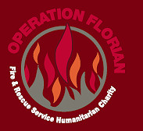**Operation Florian** - This a global charity that provides equipment and training to improve fire fighting capabilities in areas of the world that are most in need. They work in conjunction with a wide variety of international organisations from the Kosovo Protection Force to the United Nation, and incredibly they are run entirely by volunteers.
4. 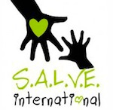**S**.**A.L.V.E International** - helps orphaned and rejected children living on the streets of Jina, eastern Uganda by taking them off the streets and into a school which provides them with much needed care, including counselling and most importantly, education. *http://www.youtube.com/watch?v=_JDZNkV0anc*
5. **Sheffield Volunteering -** is a university-run organisation supporting over 100 children and schools charities. It runs projects from visiting elderly homes, clubs for autistic children and playgroup for disabled children.
6. ** F.A.B.L.E -** A Sheffield based charity which deals with epilepsy. They raise public awareness of epilepsy through education and publicity. They also help sufferers with assistance and advice through their National Patient Support Network.

We change our charities every year to enable a large variety of organisations across the entire local and international community to benefit. Two charities selected for Bummit 2012 are:

1. 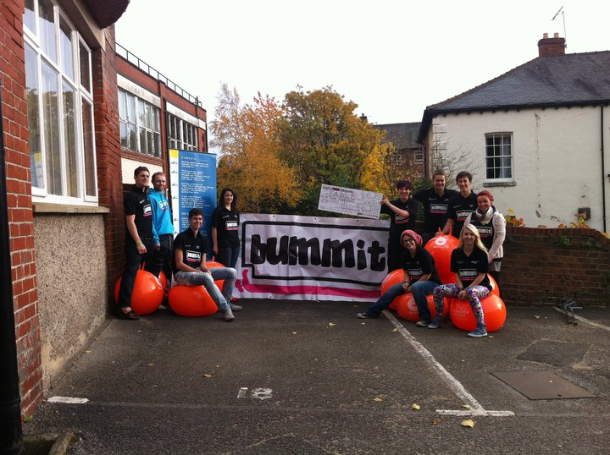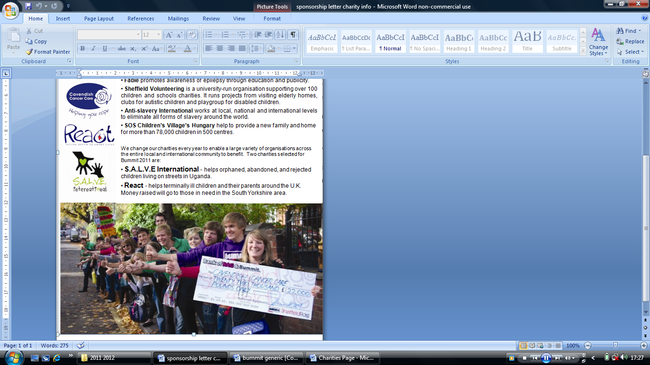**First Joint Aid Management (JAM)** -is an international charity which has assisted more than 500,000 children through nutritional feeding, health and social welfare programmes in Africa.

Charity cheque handovers 2010/11 which you can be part of in the future...